­­­­­­

**Sponsored by:**

Dr. Steve Shafroth

GlaxoSmithKline

Durham Public Schools

Texas Instruments

North Carolina Central University

Amgen Foundation

Wescott Communications



**Wednesday, May 18, 2016**

Mentoring Madness in May

M**3**

North Carolina Central University

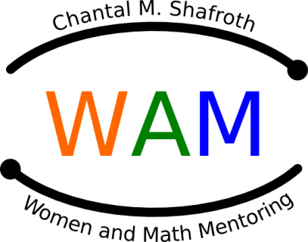

**C:\Program Files\Microsoft Office\MEDIA\CAGCAT10\j0195384.wmf**

C:\Program Files\Microsoft Office\MEDIA\CAGCAT10\j0240719.wmf

C:\Program Files\Microsoft Office\MEDIA\CAGCAT10\j0216724.wmf

**Schedule of Events**

**DPS Staff Development Center, Hillandale Road**

**5:30 - 6:30 Registration, Viewing of projects**

**Scrap Book Pages, Dinner**

**Welcome**

*Ms. Chanel Sidbury, DPS Secondary Math Specialist*

*Grades 6-8*

*Tina Ewing, Director*

**6:30 - 7:00 My Favorite Mentoring Experience,**

**Photos, Mentor Gifts**

*Dr. Laura Smith, Victoria Thio, & Sally Medling*

Mentees, think about what your group would like to share about your mentoring experience.

If your group completed a scrapbook page or did a project, tell us about it. After you speak,

please go to the Gifts Table to select a special gift for your mentor and have your picture

taken together.

**7:00 - 7:30 Mathematics Experience: DNA**

*Antia Thomas-Biotechnology, Githens*

**7:30 - 7:55 Mathematics Games** for students

*Marchia Jones, Jessica Barnwell & Mentors*

**Group Discussions** for **parents**—Room M8

*Calista Stevens & Karen Stanley*

**7:55- 8:00 Scholarship Awards**

*Arvis Bridges-Epps*

**8:00 Close-out: Evaluations by mentors and mentees**

**Prizes, Goodbyes –** WAM Committee

You need to be aware of what others are doing, applaud their efforts, acknowledge

their successes, and encourage them in their pursuits. When we all help one another,

everybody wins. ~Jim Stovall